**Assignment Details**

For this task, you can choose your country of origin or any other country that you are interested investigating. You can start by browsing through [**UNODC database**](https://sherloc.unodc.org/cld/v3/sherloc/) on cybercrime.

You will then need to carry out research to create a case study analysis on a particular cybercrime in the country of your choice. The analysis should cover the following:

1. **The country chosen and the reason it was chosen.**
2. **The cybercrime chosen, as well as the reason it was chosen and the context (a small comparison with another country could be added).**
3. **A description and explanation of the chosen cybercrime (type, nature).**
4. **An analysis of the ways the chosen country has dealt with the chosen cybercrime - on a national and international level, legislation and other tools utilised.**
5. **If available, identify the costs of this crime, and the extent of this affecting effective investigation.**
6. **If available, identify issues concerning crime investigation; focus on the gathering of evidence.**
7. **A critical examination of public and social perception generally and in your chosen country. You can draw evidence from the ‘reader comments’ section in online news reels.**
8. **The analysis should draw upon examples when available.**

**1. 選擇的國家和選擇的原因。**

**2. 選擇的網絡犯罪，以及選擇它的原因和背景（可以添加與另一個國家的小比較）。**

**3. 所選網絡犯罪（類型、性質）的描述和解釋。**

**4. 分析所選國家處理所選網絡犯罪的方式——在國家和國際層面、立法和其他使用的工具。**

**5. 如果可以，確定這種犯罪的成本，以及這種影響有效調查的程度。**

**6. 如有可能，確定與犯罪調查有關的問題；專注於證據的收集。**

**7. 對您選擇的國家的公眾和社會認知進行批判性檢查。您可以從在線新聞捲軸的“讀者評論”部分獲取證據。**

**8. 分析應利用可用的示例**

**Instructions**

For this assignment, you are required to record **a 15-minute (maximum) presentation**, along with a **transcript**of the audio file.

Given that your presentation should be about 15 minutes, you can work against a **minimum of 1500 to a maximum of 2250 words** in your oral presentation/transcript.

1. Common law

New case

The parties submit that this is one of the first cases (or in light of the scale, possibly the first) of its kind in Canada

2. Cross-Cutting country, Bulgaria, Canada, United States of America

3. ransomware

Participation in an organized criminal group

cryptocurrency

4. An undercover agent with the U.S. Federal Bureau of Investigation (FBI) transferred bitcoin from the AlphaBay darknet market (DNM) to Helix. Helix then exchanged the bitcoin for bitcoin that were not traceable to the DNM.

Criminal Code, 18 U.S.C. §

**Legislation / Statute / Code:**

Section 430(5) of the Criminal Code

The defendant was charged under s. 430(5)(a) of the Criminal Code

**Charge details:**

Mischief in relation to computer data

**Verdict:**

Guilty

**Legislation / Statute / Code:**

Section 342.1 of the Criminal Code

The defendant was charged under s. 342.1(1)(a) of the Criminal Code.

**Charge details:**

Unauthorized use of computer

**Verdict:**

Guilty

**Legislation / Statute / Code:**

Section 346(1.1) of the Criminal Code

The defendant was charged under s. 346(1.1)(b) of the Criminal Code.

**Charge details:**

Extortion (two counts)

**Verdict:**

Guilty

**Legislation / Statute / Code:**

Section 467.11 of the Criminal Code

**Charge details:**

Participation in activities of criminal organization

**Verdict:**

Guilty

5. 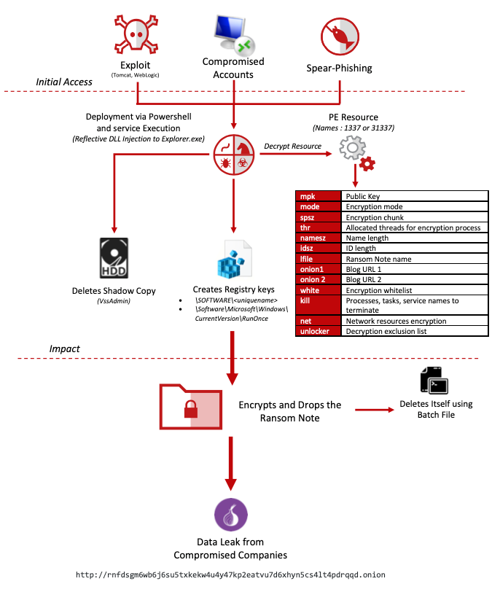

6. Eventually, based on internet protocol addresses, data gleaned from U.S. investigations into various Apple, Google, Microsoft, and Mega.nz accounts, aliases, email addresses, and personal information revealed on social media platforms, the Defendant was identified by the Canadian authorities

7. In the subsequent sentencing, the mitigating and aggravating circumstances were evaluated, inter alia the fact that he pleaded guilty at the earliest point in time and that he cooperated with authorities as well as the fact that the offences involved many victims, over an extended period of time, and that they caused significant damage. The Justice finally sentenced the defendant to six years and eight months in prison. In addition, restitution payments and the forfeiture of certain proceeds of crime were ordered.

https://www.mcafee.com/blogs/other-blogs/mcafee-labs/take-a-netwalk-on-the-wild-side/